**Digital Assignment-1**

**Object Oriented Programming (Lab)**

**Submitted By: Hari Krishna Shah**

**VIT ID: 21BCS0167**

**Google Drive Link:**

<https://drive.google.com/drive/folders/1QQxJ9Y0CKSeKKXRkVQ-R92jdA3bDtIqI?usp=sharing>

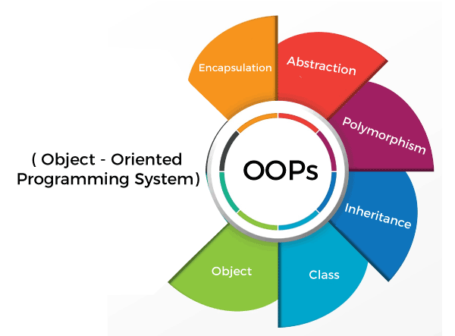

Ques 1. Develop a function that returns through its reference parameters

both the GCD and LCM values passed to the function.

void get_Gcd_Lcm (int &gcd, int &lcm, int num1, int num2);

Answer:

#include <iostream>

**using** **namespace** std**;**

*//Coded by Hari Krisnna Shah*

**void** get_gcd_and_lcm**(int** **&**gcd**,** **int** **&**lcm**,** **int** num1**,** **int** num2**);**

**int** main**(){**

**int** hcf**,** lcm**;**

**int** num1**,** num2**;**

cout**<<"Enter two numbers to calculate gcd and lcm: ";**

cin**>>**num1**>>**num2**;**

get_gcd_and_lcm**(**hcf**,** lcm**,** num1**,** num2**);**

cout**<<"The gcd and lcm of the two number "<<**num1**<<" and "<<**num2**<<" are given below."<<**endl**;**

cout**<<"GCD: "<<**hcf**<<**endl**;**

cout**<<"LCM: "<<**lcm**<<**endl**;**

**}**

**void** get_gcd_and_lcm**(int** **&**gcd**,** **int** **&**lcm**,** **int** num1**,** **int** num2**){**

**int** i **=** 1**;**

**int** j **=** 1**;**

**while(**i**<=**num1 **&&** i**<=**num2**){**

**if((**num1**%**i **==** 0**)** **&&** **(**num2**%**i **==** 0**)){**

gcd **=** i**;**

**}**

i **+=** 1**;**

**}**

j **=** 1**;**

**while((**j**%**num1 **!=** 0**)** **||** **(** j**%**num2 **!=** 0**)){**

j **+=** 1**;**

**}**

lcm **=** j**;**

**}**

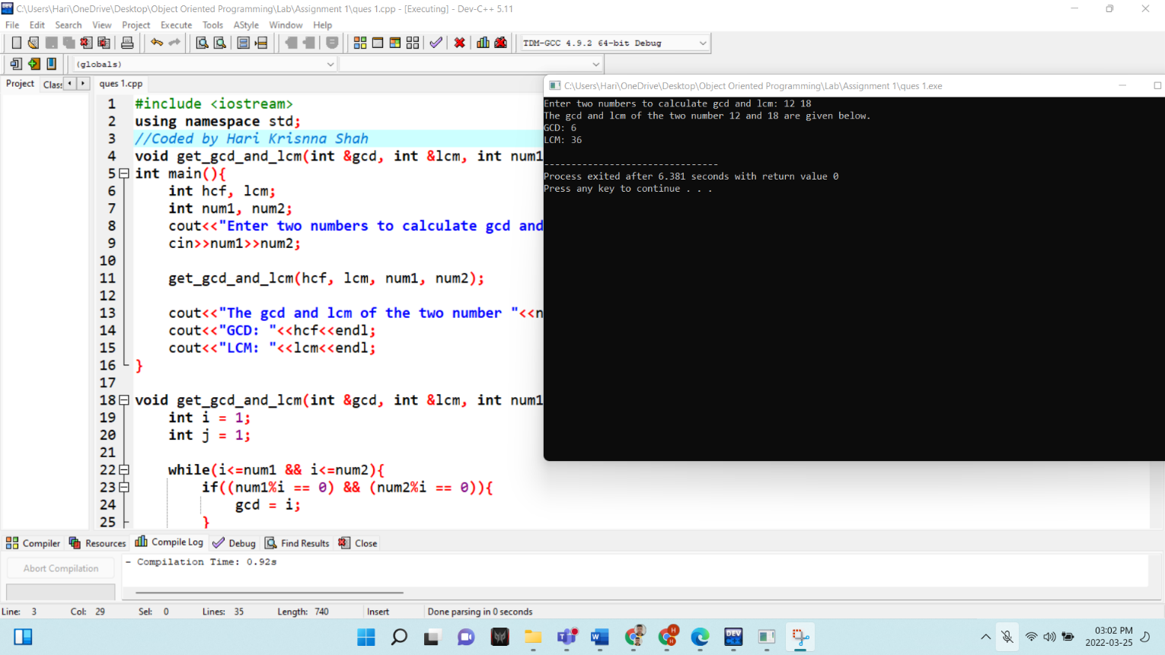

Ques 2. Develop a program to read the given two time objects which has the time duration taken by the two individuals to complete the set of tasks (Ex.Task1 to Task5). Identify who is efficient in each of the task and in overall all of tasks by comparing the time taken to complete each of the task by individual and the overall time to complete all of the tasks.

Answer:

#include <iostream>

#include <cstring>

**using** **namespace** std**;**

*//Coded by Hari Krishna Shah*

**class** time**{**

**private:**

**char** name**[**50**];**

**float** time_taken**[**5**];**

**float** average_time**;**

**float** total_time**;**

**public:**

**void** get_details**();**

**void** calculate_time**();**

**void** display_all**();**

**void** compare**(class** time b**);**

**};**

**int** main**(){**

**class** time t**[**2**];**

cout**<<"\t\tThis program compares two time objects and provides statistics based on the comparision."<<**endl**;**

**for(int** i **=** 0**;** i**<**2**;** i**++){**

cout**<<"Enter the details for the object number "<<** i**+**1 **<<" below."<<**endl**;**

t**[**i**].**get_details**();**

t**[**i**].**calculate_time**();**

cout**<<**endl**;**

**}**

**for(int** i **=** 0**;** i**<**2**;** i**++){**

cout**<<"The calculated details for the object number "<<**i**+**1**<<" is given below."<<**endl**;**

t**[**i**].**display_all**();**

cout**<<**endl**<<**endl**;**

**}**

cout**<<"The detailed comparision between the two objects is given below."<<**endl**;**

t**[**0**].**compare**(**t**[**1**]);**

**return** 0**;**

**}**

**void** time**::**get_details**(){**

cout**<<"Enter the name for the worker: ";**

cin**>>**name**;**

cout**<<"Enter the time take taken by "<<**name**<<" to do the 5 tasks below in terms of hours."<<**endl**;**

**for(int** i **=** 0**;** i**<**5**;** i**++){**

cout**<<"Time Taken to do task "<<**i**+**1**<<" in terms of hours: ";**

cin**>>**time_taken**[**i**];**

**}**

cout**<<"All details collected successfully."<<**endl**<<**endl**;**

**}**

**void** time**::**calculate_time**(){**

**float** total_temp**=**0**,** average_temp**;**

**for(int** i **=** 0**;** i**<**5**;** i**++){**

total_temp **+=** time_taken**[**i**];**

**}**

average_temp **=** total_temp**/**5**;**

total_time **=** total_temp**;**

average_time **=** total_time**/**5**;**

**}**

**void** time**::**display_all**(){**

cout**<<"The details of time taken by "<<**name**<<" to do 5 tasks are given below."<<**endl**;**

cout**<<"Name: "<<**name**<<**endl**;**

**for(int** i **=** 0**;** i**<**5**;** i**++){**

cout**<<"Time taken for task"<<**i**+**1**<<" in hours:"<<**time_taken**[**i**]<<**endl**;**

**}**

cout**<<"Total time taken to do 5 tasks in hours: "<<**total_time**<<**endl**;**

cout**<<"Average time taken to finish a task in hours: "<<**average_time**<<**endl**;**

**}**

**void** time**::**compare**(class** time b**){**

**float** percent**;;**

**for(int** i **=** 0**;** i**<**5**;** i**++){**

**if(**time_taken**[**i**]>**b**.**time_taken**[**i**]){**

cout**<<**b**.**name**<<" does the task"<<**i**+**1**<<" faster than "<<**name**<<" ."<<**endl**;**

cout**<<**b**.**name**<<" takes just "<<**b**.**time_taken**[**i**]<<" hours to do the task"<<**i**+**1**<<" but "<<**name**<<" takes "<<**time_taken**[**i**]<<" hours to do the same task"<<**endl**;**

cout**<<**endl**;**

**}**

**else** **if(**time_taken**[**i**]<**b**.**time_taken**[**i**]){**

cout**<<**name**<<" does the task"<<**i**+**1**<<" faster than "<<**b**.**name**<<" ."<<**endl**;**

cout**<<**name**<<" takes just "<<**time_taken**[**i**]<<" hours to do the task"<<**i**+**1**<<" but "<<**b**.**name**<<" takes "<<**b**.**time_taken**[**i**]<<" hours to do the same task"<<**endl**;**

cout**<<**endl**;**

**}**

**else{**

cout**<<"Both "<<**name**<<" and "<<**b**.**name**<<" take equal time of "<<**b**.**time_taken**[**i**]<<" hours to do the task"<<**i**+**1**<<" ."<<**endl**;**

cout**<<**endl**;**

**}**

**}**

cout**<<**endl**<<**endl**;**

cout**<<**name**<<" can finish all the 5 tasks in "<<**total_time**<<" hours and "<<**b**.**name**<<" needs "<<**b**.**total_time**<<" hours to do all the 5 tasks."<<**endl**;**

cout**<<**name**<<" takes "<<**average_time**<<" hours on average to do a task and "<<**b**.**name**<<" needs "<<**b**.**average_time**<<" hours on average to finish a task.";**

cout**<<**endl**;**

**if(**total_time**>**b**.**total_time**){**

percent **=** **(**total_time**/**b**.**total_time**)\***100**;**

cout**<<**b**.**name**<<" is "<<**percent**-**100**<<"% faster than "<<**name**<<**endl**;**

**}**

**else** **if(**b**.**total_time**>**total_time**){**

percent **=** **(**b**.**total_time**/**total_time**)\***100**;**

cout**<<**name**<<" is "<<**percent**-**100**<<"% faster than "<<**b**.**name**<<**endl**;**

**}**

**else{**

cout**<<"Both "<<**name**<<" and "<<**b**.**name**<<" have the same working speed."<<**endl**;**

**}**

**}**

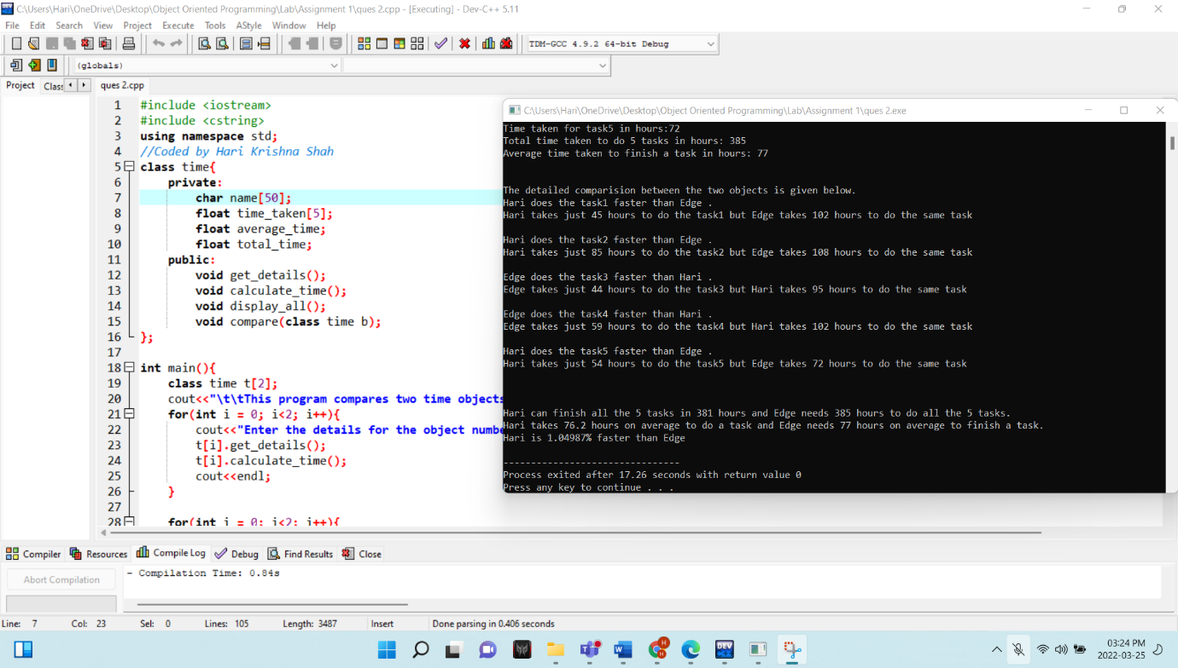

Ques 3. A book store maintains the inventory of books that are being sold in the store. The list includes the details such as title, author, publisher, price and stock position. Whenever, a customer asks for a book, the sales person inputs the title and author and system searches the list and displays the whether the book is available or not. If the book is available, it displays the total no. of copies available and if it is not available, it displays “STOCK - NOT AVAILABLE - YET TO COME”. Page 2 of 2 If, the requested no. of copies available, total cost of the available copies are displayed. Otherwise, it displays “Required copies are not available”. Develop an OOP using classes and objects. Include necessary constructors and destructor to maintain the objects space and their usage effectively.

Answer:

#include <iostream>

#include <cstring>

#include <string>

#include <malloc.h>

**using** **namespace** std**;**

*//Coded by Hari Krishna Shah*

**class** books**{**

**private:**

**char** title**[**50**];**

**char** author**[**50**];**

**char** publication**[**50**];**

**int** year_pub**;**

**float** price**;**

**int** stock_position**;**

**public:**

books**(){**

year_pub **=** 2022**;** *// current year*

stock_position **=** 0**;** *// until and unless specified*

strcpy**(**publication**,** **"Shah_Library");** *//default owner and publisher of the book*

**}**

**~**books**(){**

*// objects are intialized to these data values if they go out of scope. It protects objects from data leak.*

strcpy**(**title**,** **"XXXXX");**

strcpy**(**author**,** **"XXXXX");**

strcpy**(**publication**,** **"XXXXX");**

price **=** 0**;**

price **=** 99999**;**

stock_position **=** 99999**;**

**}**

**void** get_details**();**

string return_title**();**

**void** display**();**

string return_author**();**

**int** return_price**();**

**int** request_handle**(char** book_title**[**50**],** **char** book_author**[**50**],** **int** required_copies**);**

**void** display_message**(int** request**,** **int** required_copies**);**

**};**

**void** books**::**get_details**(){**

cout**<<"Enter the title of the book: ";**

cin**>>**title**;**

cout**<<"Enter the author of the book: ";**

cin**>>**author**;**

cout**<<"Enter the publisher of the book: ";**

cin**>>**publication**;**

cout**<<"Enter the year of publication of the book: ";**

cin**>>**year_pub**;**

cout**<<"Enter the price of the book: ";**

cin**>>**price**;**

cout**<<"Enter the number of copies: ";**

cin**>>**stock_position**;**

**}**

**void** books**::**display**(){**

cout**<<"Book Title: "<<**title**<<**endl**;**

cout**<<"Author: "<<**author**<<**endl**;**

cout**<<"Publisher: "<<**publication**<<**endl**;**

cout**<<"Year of publication: "<<**year_pub**<<**endl**;**

cout**<<"Price: "<<**price**<<**endl**;**

cout**<<"Number of copies available: "<<**stock_position**<<**endl**<<**endl**;**

**}**

string books**::**return_title**(){**

**return** title**;**

**}**

string books**::**return_author**(){**

**return** author**;**

**}**

**int** books**::**return_price**(){**

**return** price**;**

**}**

**int** books**::**request_handle**(char** book_title**[**50**],** **char** book_author**[**50**],** **int** required_copies**){**

**if((**strcmp**(**book_title**,** title**)==**0**)** **&&** **((**strcmp**(**book_author**,** author**)** **==**0**))** **&&** stock_position **>=** required_copies**){**

**return** 1**;**

**}**

**else** **if((**strcmp**(**book_title**,** title**)==**0**)** **&&** **((**strcmp**(**book_author**,** author**)** **==**0**))){**

**return** 2**;**

**}**

**}**

**void** books**::**display_message**(int** request**,** **int** required_copies**){**

**if(**request **==** 1**){**

cout**<<"\nThe book "<<**title**<<" by the author "<<**author**<<" is available with us."<<**endl**;**

cout**<<"There are "<<**stock_position**<<" number of copies available."<<**endl**;**

cout**<<"The price for the each copy of the book is "<<**price**<<" . So, total price for "<<**required_copies**<<" number of copies is Rs "<<**price**\***required_copies**<<". "<<**endl**;**

**}**

**else** **if(**request **==** 2**){**

cout**<<"\nSorry, there are only "** **<<**stock_position**<<" number of copies of the book "<<**title**<<" by the author "<<**author**<<" available with us."<<**endl**;**

cout**<<"Required number of copies not available.!!!"<<**endl**;**

cout**<<"We are short by "<<**required_copies **-**stock_position**<<" number of copies."<<**endl**;**

**}**

**}**

**int** main**(){**

**class** books **\***b**;**

b **=** **(class** books **\*)** **(**malloc**(sizeof(class** books**)));**

**static** **int** book_count **=** 0**;**

**int** temp1_count **=** 0**,** temp2_count **=** 0**;**

**int** option**;**

**do{**

cout**<<"\t\tThis program is made by Hari Krishna Shah !!!"<<**endl**;**

cout**<<"Welcome to the main menu"<<**endl**;**

cout**<<"Enter an option from the menu below\n \**

**Enter 1 to add books to the database\n \**

**Enter 2 to display all the books\n \**

**Enter 3 to sort the book in ascending order\n \**

**Enter 4 to search the book by author name\n \**

**Enter 5 to display books whose price is below certain price\n \**

**Enter 6 to process a book purchase request \n \**

**Enter -1 to quit the program"<<**endl**;**

cout**<<"Enter your option here: ";**

cin**>>**option**;**

cout**<<**endl**;**

**switch(**option**){**

**case** **-**1**:** **{**

**break;**

**}**

**case** 1**:{**

cout**<<"Enter the number of books you want to add: ";**

cin**>>**temp1_count**;**

book_count **+=** temp1_count**;**

cout**<<**endl**;**

**for(;** temp2_count**<**book_count**;** temp2_count**++){**

cout**<<"Enter the details for book number "<<**temp2_count**+**1**<<" :"<<**endl**;**

b **=** **(class** books **\*)** **(**realloc**(**b**,** book_count**\*sizeof(class** books**)));**

b**[**temp2_count**].**get_details**();**

cout**<<**endl**;**

**}**

**break;**

**}**

**case** 2**:{**

**if(**book_count **==** 0**){**

cout**<<"The database is empty. Add some books first."<<**endl**;**

**break;**

**}**

**for(int** i **=** 0**;** i**<**book_count**;** i**++){**

cout**<<"Details for book number "<<**i**+**1**<<" is given below."<<**endl**;**

b**[**i**].**display**();**

cout**<<**endl**;**

**}**

**break;**

**}**

**case** 3**:{**

**if(**book_count **==** 0**){**

cout**<<"There's isn't any book in the database. Add some books to the database first."<<**endl**;**

**break;**

**}**

**class** books temp**;**

**for(int** i **=** 0**;** i**<**book_count**;** i**++){**

**for(int** j **=** i**+**1**;** j**<**book_count**;** j**++){**

**if((**b**[**i**].**return_title**().**compare**(**b**[**j**].**return_title**()))>**0**){**

temp **=** b**[**i**];**

b**[**i**]** **=** b**[**j**];**

b**[**j**]** **=** temp**;**

**}**

**}**

**}**

cout**<<"The books have been sorted in ascending order according to book title successfully."<<**endl**;**

**break;**

**}**

**case** 4**:{**

**if(**book_count **==** 0**){**

cout**<<"\nThere's isn't any book in the database. Add some books to the database first."<<**endl**;**

**break;**

**}**

**char** search**[**50**];**

cout**<<"Enter the author name to search in the database: ";**

cin**>>**search**;**

**int** flag1 **=** 0**;**

**for(int** i **=** 0**;** i**<**book_count**;** i**++){**

**if(**b**[**i**].**return_author**().**compare**(**search**)==**0**){**

**if(**flag1 **==** 0**){**

cout**<<"\nFollowing book is authored by "<<**search**<<"."<<**endl**;**

**}**

cout**<<"Book number: "<<**flag1**+**1**<<"."<<**endl**;**

b**[**i**].**display**();**

cout**<<**endl**;**

flag1 **+=** 1**;**

**}**

**}**

**if(**flag1 **==** 0**){**

cout**<<"There isn't any book authored by "<<**search**<<" in the database.\nTry again with another author name."<<**endl**;**

**}**

**else{**

cout**<<"Total "<<**flag1**<<" numbers of books were found in the database."<<**endl**;**

**}**

**break;**

**}**

**case** 5**:**

**{**

**if(**book_count **==** 0**){**

cout**<<"There's isn't any book in the database. Add some books to the database first."<<**endl**;**

**break;**

**}**

**int** price**;**

cout**<<"Enter the price to find books below that price: ";**

cin**>>**price**;**

**int** flag **=** 0**;**

**for(int** i **=** 0**;** i**<**book_count**;** i**++){**

**if(**b**[**i**].**return_price**()<**price**){**

cout**<<"Match Found. Book number: "<<**flag**+**1**<<**endl**;**

b**[**i**].**display**();**

flag **+=** 1**;**

**}**

**}**

**if(**flag **==** 0**){**

cout**<<"There isn't any book below Rs."<<**price**<<" in the database."<<**endl**;**

**}**

**break;**

**}**

**case** 6**:{**

**if(**book_count **==** 0**){**

cout**<<"There book database is empty. Add some books first."<<**endl**;**

**}**

**else{**

**char** book_title**[**50**],** book_author**[**50**];**

**int** required_copies**,** flag **=** 0**,** result**=**0**;**

cout**<<"Enter the title of the book you want to purchase: ";**

cin**>>**book_title**;**

cout**<<"Enter the author of the book: ";**

cin**>>**book_author**;**

cout**<<"Enter the required number of copies: ";**

cin**>>**required_copies**;**

**for(int** i **=** 0**;** i**<**book_count**;** i**++){**

result **=** b**[**i**].**request_handle**(**book_title**,** book_author**,** required_copies**);**

**if(**result **==** 1 **||** result **==** 2**){**

b**[**i**].**display_message**(**result**,** required_copies**);**

flag **+=** 1**;**

**break;**

**}**

**}**

**if(**flag **==** 0**){**

cout**<<"\nSTOCK- NOT Available. YET TO COME."<<**endl**;**

**}**

**}**

**break;**

**}**

**default:{**

cout**<<"Enter a valid option and try again."<<**endl**;**

**break;**

**}**

**}**

cout**<<**endl**;**

**}**

**while(**option **!=** **-**1**);**

cout**<<"Thank you for using the program.\nPlease drop a feedback or a comment."<<**endl**;**

**return** 0**;**

**}**

